NTFB Civil Rights Training (1)

1. NTFB Civil Rights training 2023

1.1 Civil Rights Training
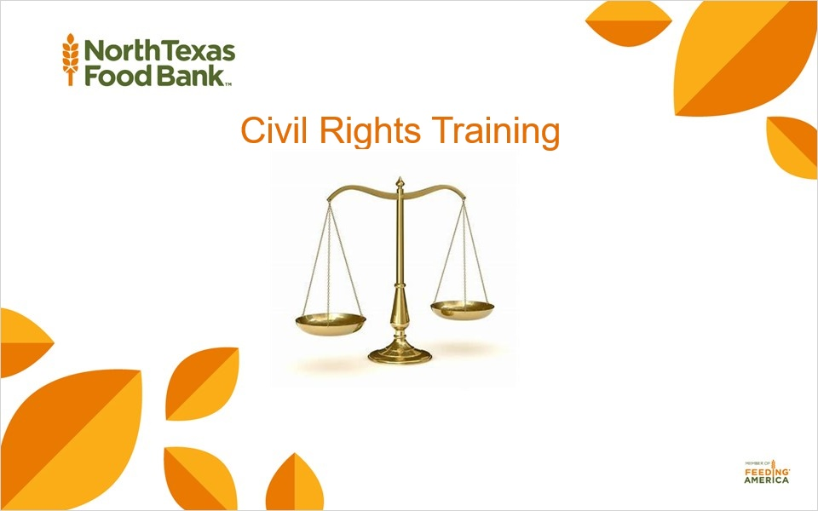

1.2 Introduction
Notes:
Hello, welcome to the North Texas Food Bank's training on civil rights. Before we get started, please notice, the resource tab located in the right-hand top corner of each slide for printable forms and other needed documents.
For your convenience, we have also attached a full printable Civil Rights training document for you,,, your staff,,, or volunteers if you are unable to use agency university to complete the training.
Using the full printable document is not recommended because it will not provide the full agency university experience.
We highly suggest that you complete your Civil Rights training on Agency university if you are able.
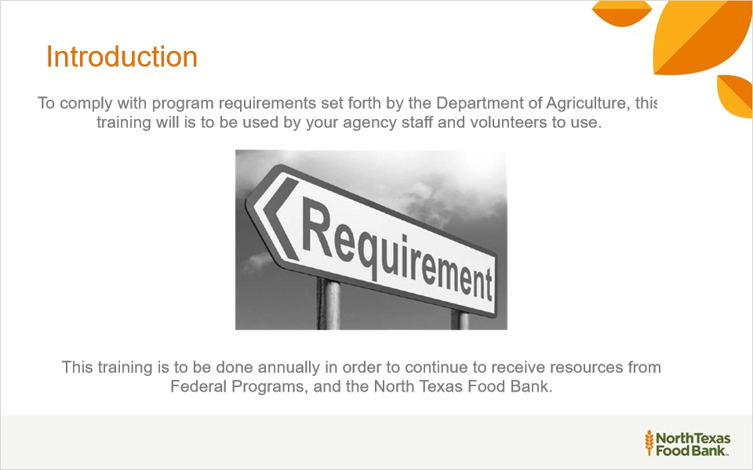
Notes:
Agencies are responsible for training their local sites, including “frontline staff” who interact with applicants or participants on an annual basis.

1.3 Goals of Civil Rights Training
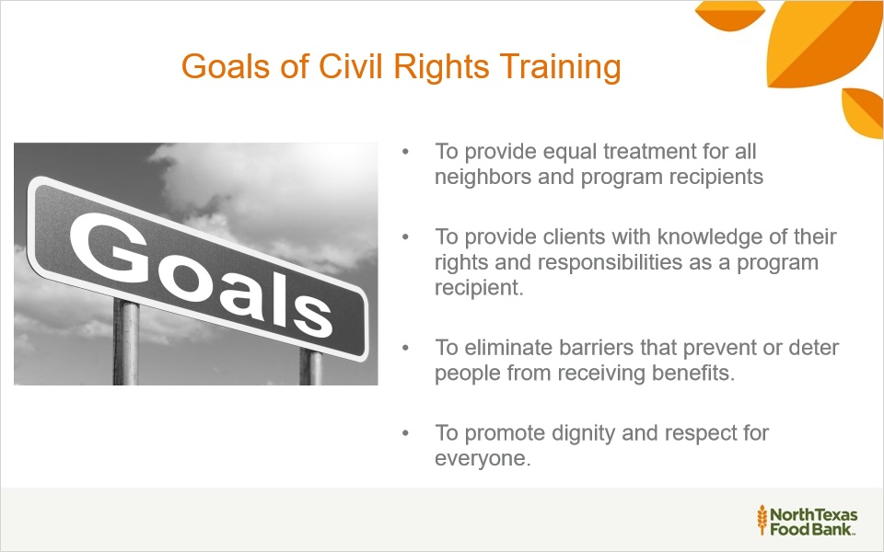
Notes:
Let's review the goals of the Civil Rights Training! First, to provide equal treatment for all neighbors and recipients! Secondly, to provide neighbors and recipients with knowledge of their rights and responsibilities!
Thirdly, to eliminate any barriers to prevent applicants from receiving benefits. And lastly, to promote dignity and respect for everyone.

1.4 Table of Contents
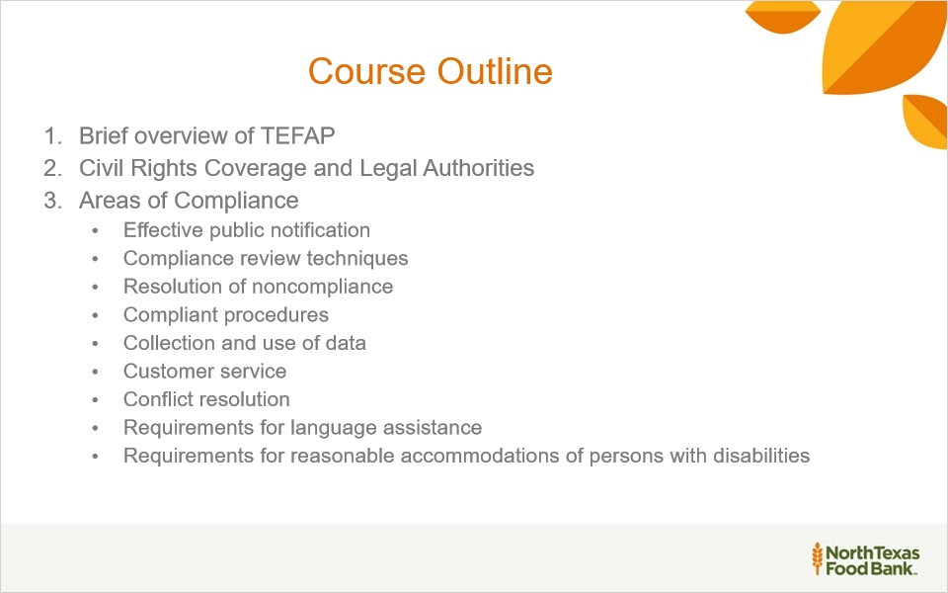
Notes:
In this training we will cover a brief overview of TEFAP, Civil Rights Coverage and Legal Authorities and areas of compliance.

1.5 Civil Rights Training Requirements for Staff and Volunteers
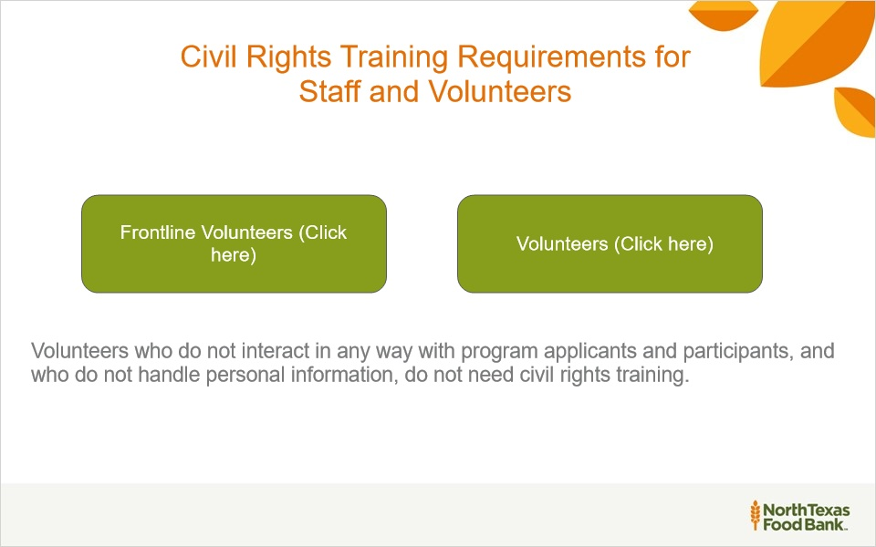
Notes:
FNS requires civil rights training for people involved in all levels of the administration of programs that receive federal financial assistance. Civil rights training requirements for volunteers should be approached in the following manner:

If there is a concern that any particular volunteer cannot understand and/or abide by the training and civil rights requirements, then that individual should not interact in any way with program applicants and participants or handle personal information.

Frontline Volunteers (Slide Layer)
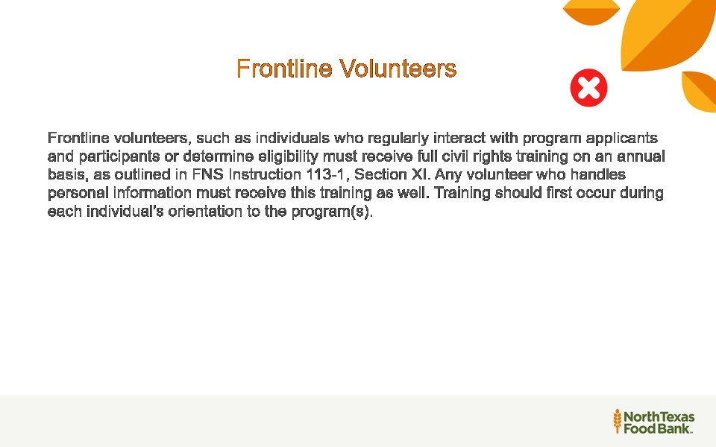

Volunteers who do not handle personal Info (Slide Layer)
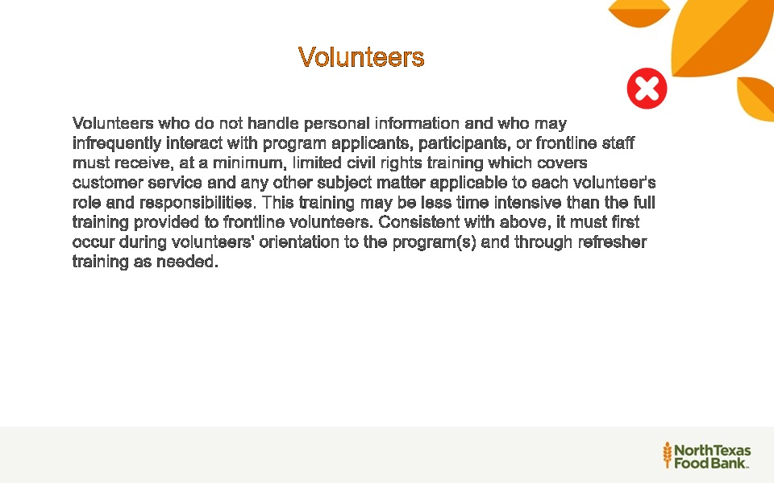

1.6 The Emergency Food Assistance Program (TEFAP)
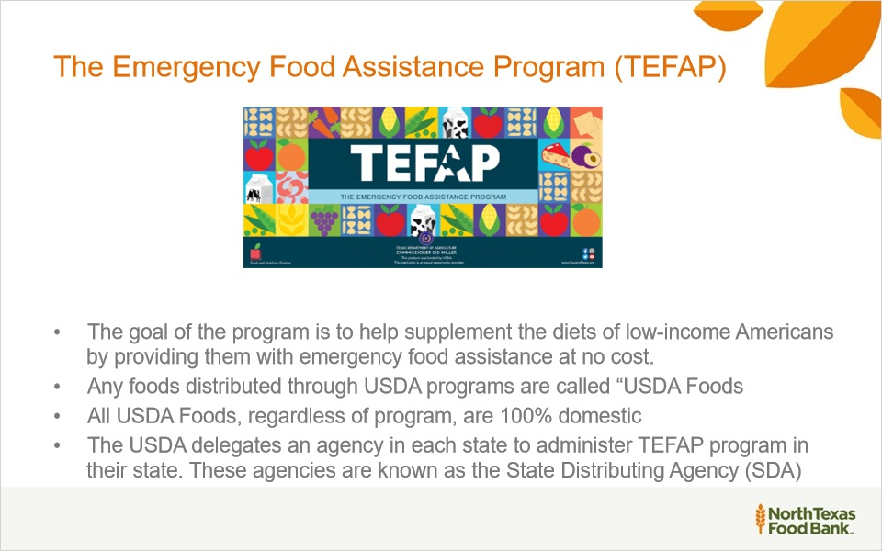
Notes:
TEFAP is a federal program hosted by the Food and Nutrition Service (FNS) branch of the United States Department of Agriculture (USDA).

1.7 Civil Rights Legal Authorities cont.
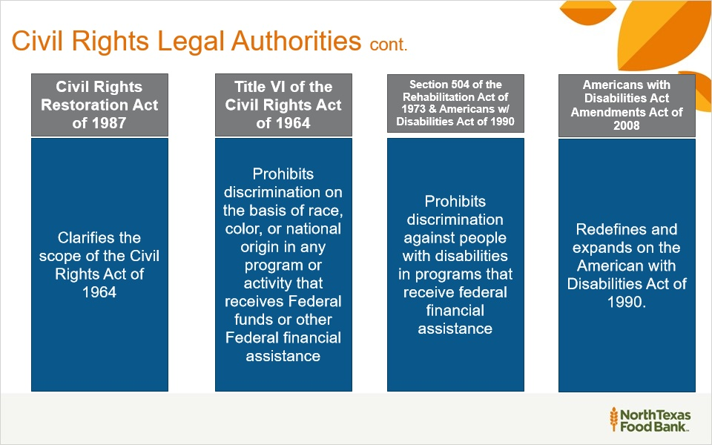
Notes:
On the next 4 slides you will learn about the following laws and regulations that guide us on how to best be fair and equitable to our neighbors. View the resource links to view all documents that are available.

1.8 Civil Rights Legal Authorities cont.
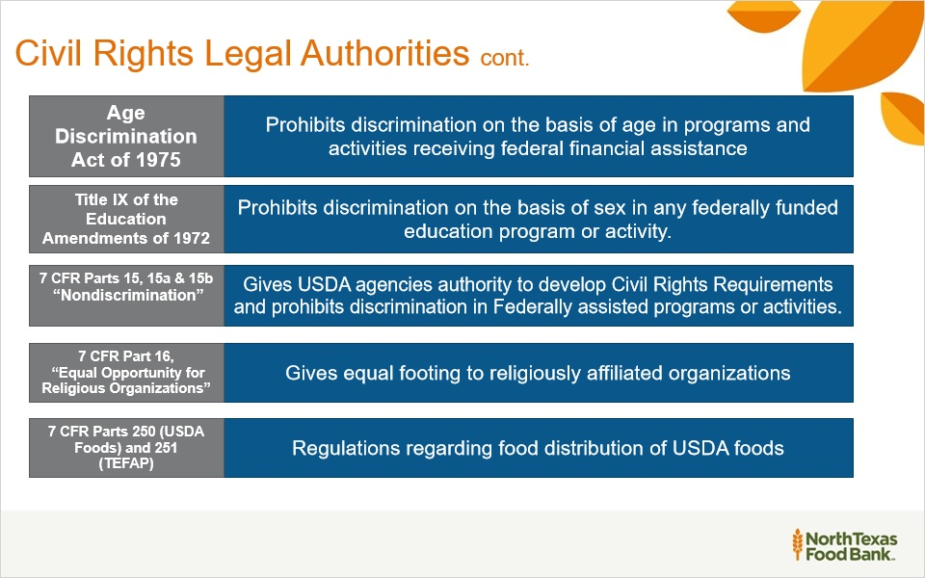

1.9 Civil Rights Legal Authorities cont.
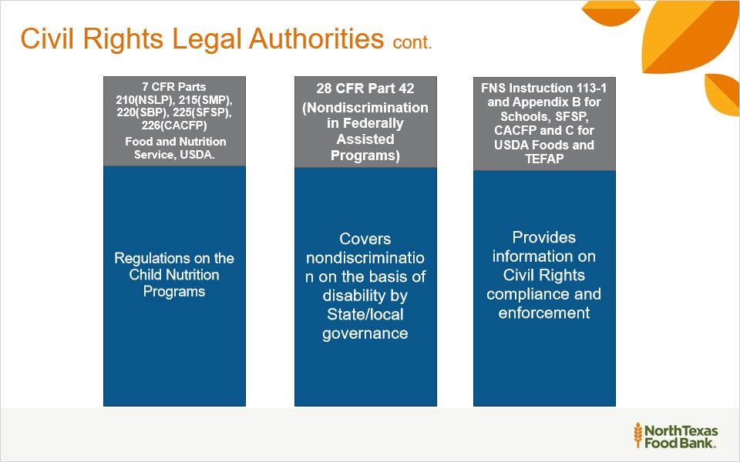

1.10 Civil Rights Legal Authorities cont.
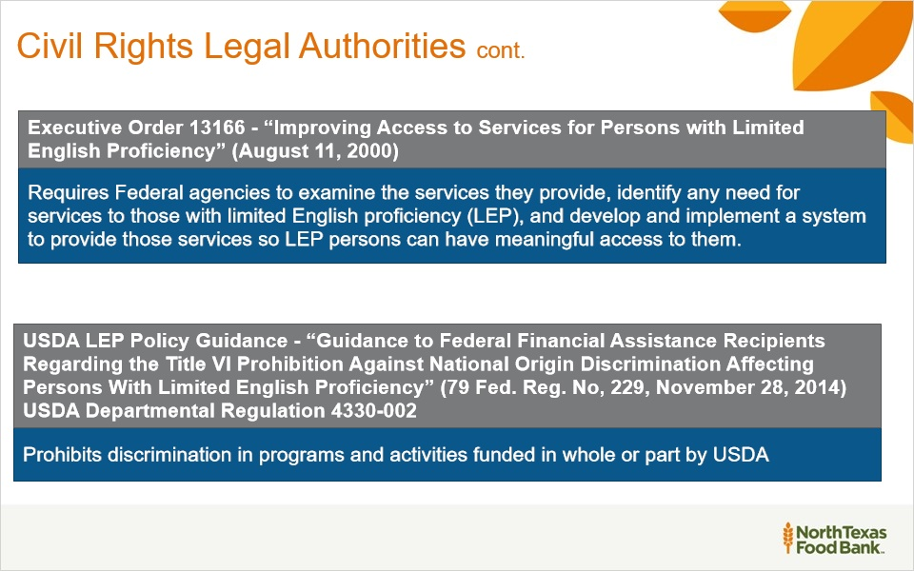

1.11 Discrimination
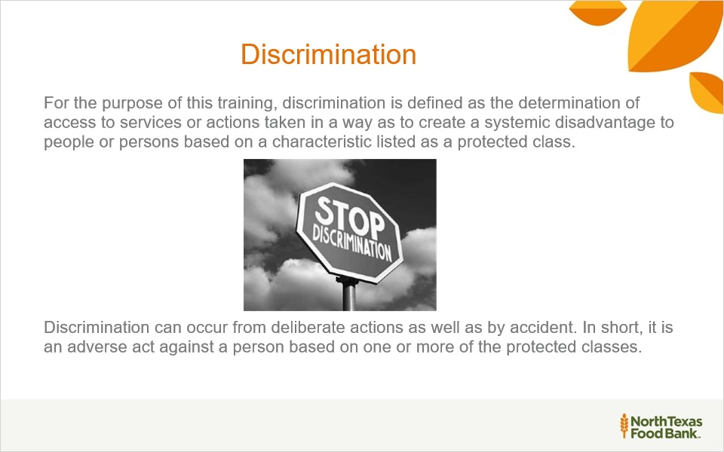
Notes:
Simply put, it is illegal to be unfair to people based on race, sex, color, age, national origin, or disability. It is also unlawful to retaliate against someone who made a civil rights complaint. They must be treated the same as everyone else, regardless of previous issues.

1.12 Types of Discrimination
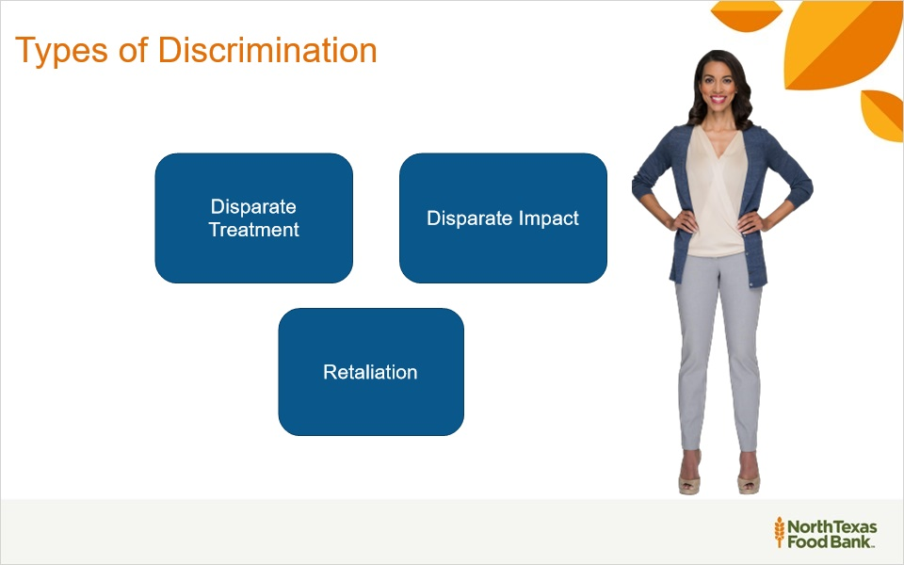
Notes:
This slide covers the different types of discrimination.
Click on each box to review a full description of disparate treatment, disparate impact, and retaliation.

Disparate treatment (Slide Layer)
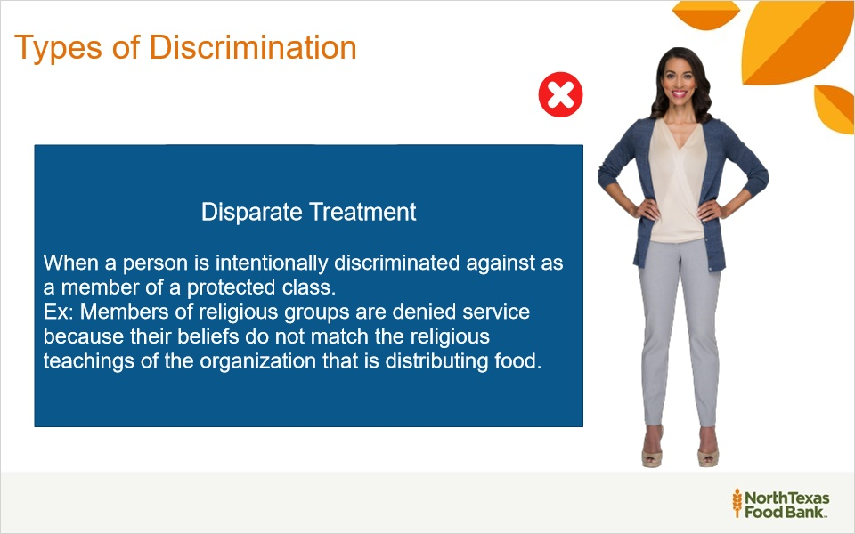

Disparate Impact (Slide Layer)
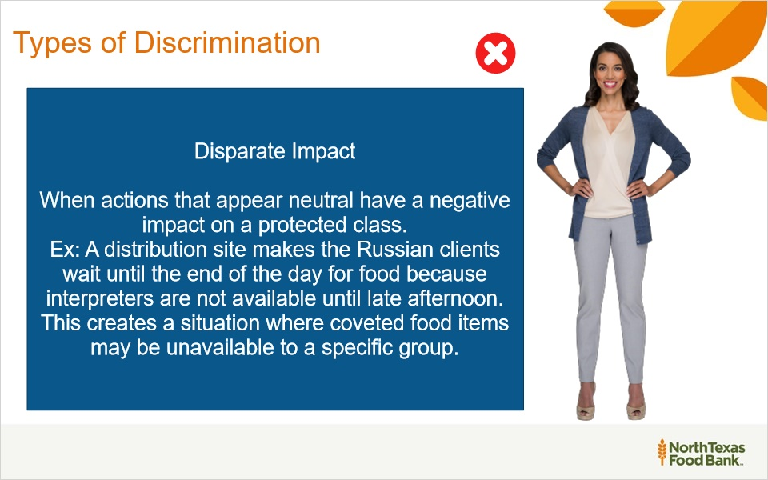

Retaliation (Slide Layer)
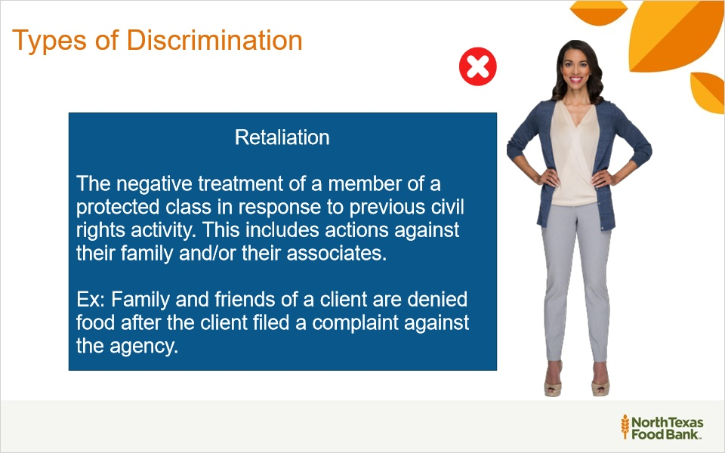

1.13 Eligibility Requirements vs Discrimination
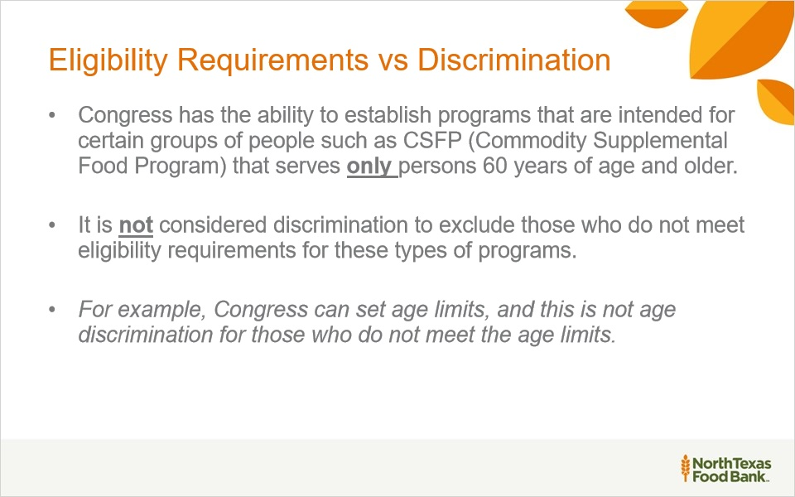
Notes:
Eligibility Requirements versus Discrimination

Congress has the ability to establish programs that are intended for certain groups of people such as CSFP.
which stands for Commodity Supplemental Food Program. This program is designed to only serve persons 60 years of age and older.
This is not considered discrimination to exclude those who do not meet eligibility requirements for these types of programs.
For example, if Congress sets an age limit to qualify for a program, this is not age discrimination for those who do not meet the age requirements.

1.14 Public Notification
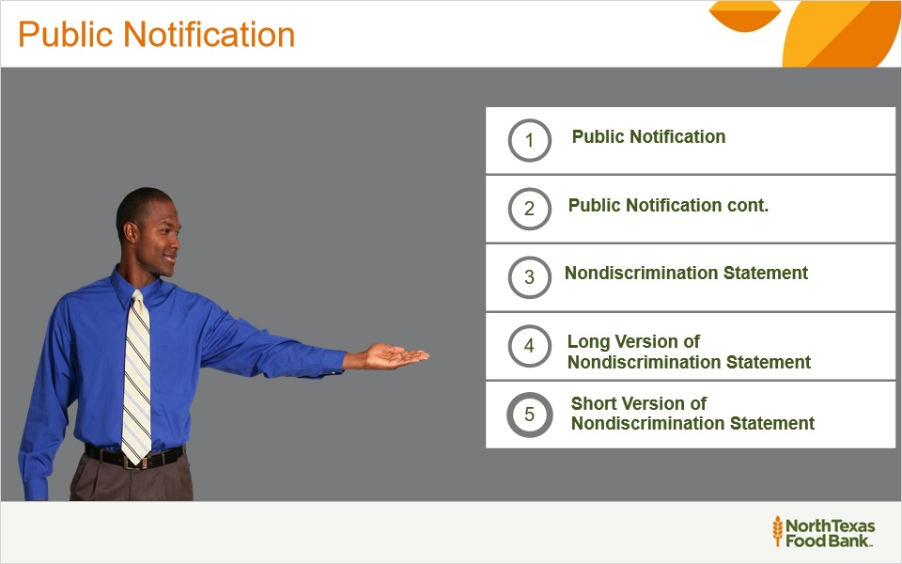
Notes:
In these slides you will learn about the civil rights requirements for notifying the public about TEFAP and various statements that are available.

Public Notification Systems (Slide Layer)
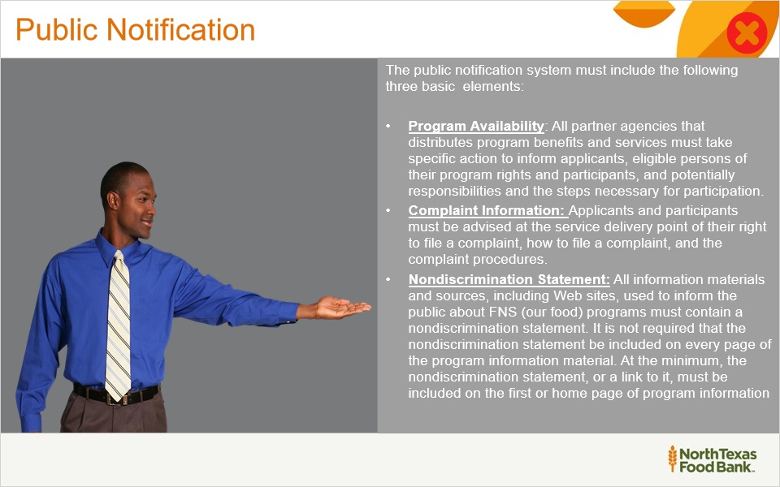

Public Notification Cont. (Slide Layer)
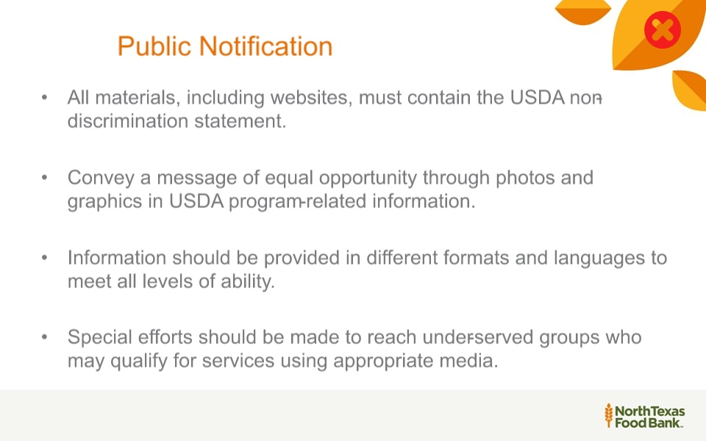

Nondiscrimination Statement (Slide Layer)
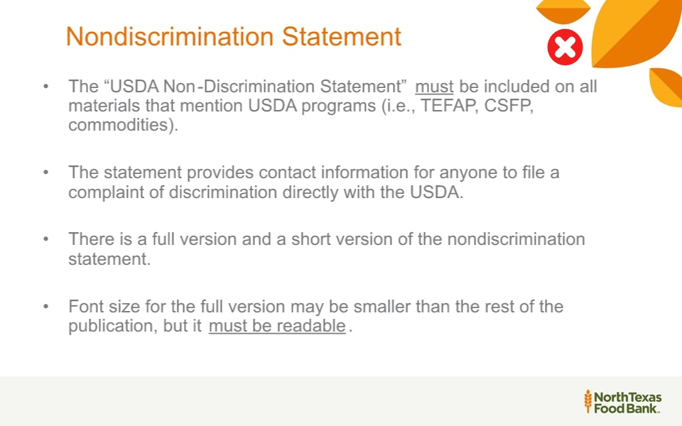

Long Version of the Nondiscrimination Statement (Slide Layer)
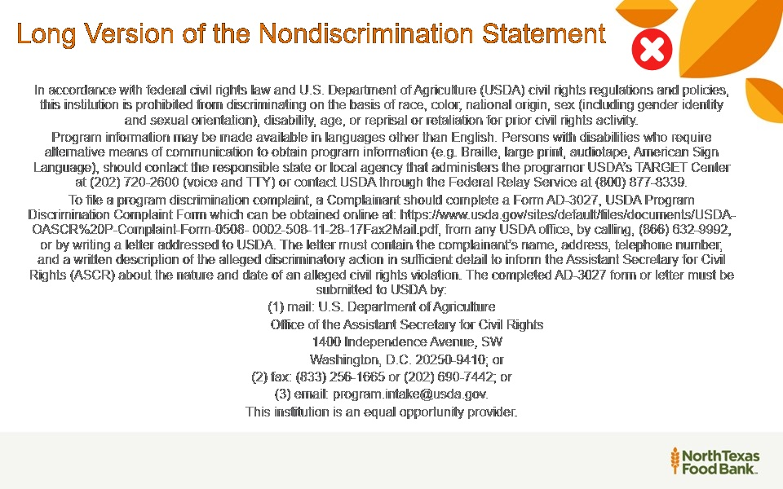

Short Version of the Nondiscrimination Statement (Slide Layer)
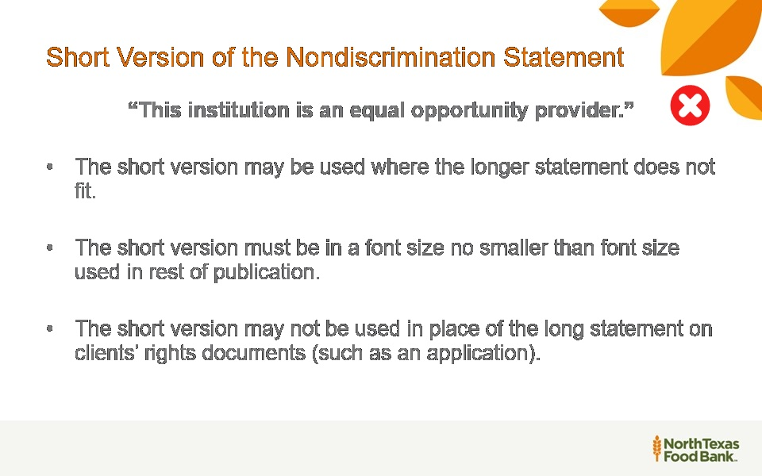

1.15 “...And Justice for All” Poster
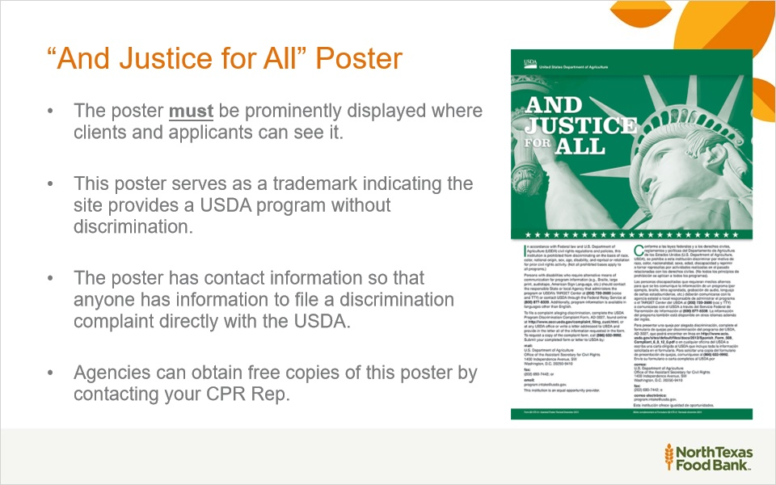
Notes:
The “And Justice for All” Poster must be posted where all neighbors and applicants can see it. This serves as a trademark for sites providing a USDA program without discrimination.
Agencies can obtain free copies of this poster by contacting your CPR representative.

1.16 Public Notification: Basic Elements
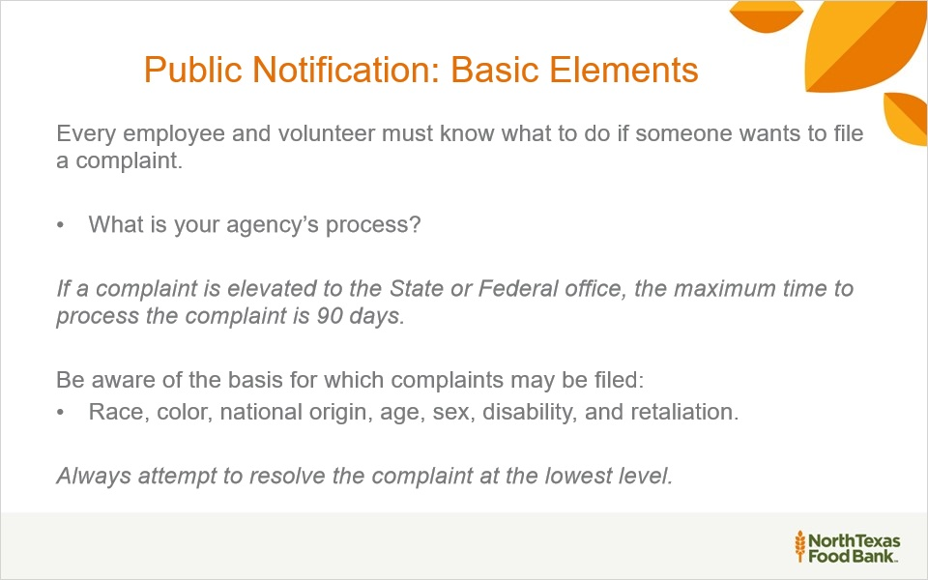
Notes:
Everyone has the right to file a complaint of discrimination. Never discourage someone from filing a complaint or voicing concerns of discrimination.
Complaints must be filed within 180 days from the alleged act of discrimination, with some exceptions. Complaints may be written, verbal or anonymous and confidentiality is important and must be maintained.

1.17 Civil Rights Complaints
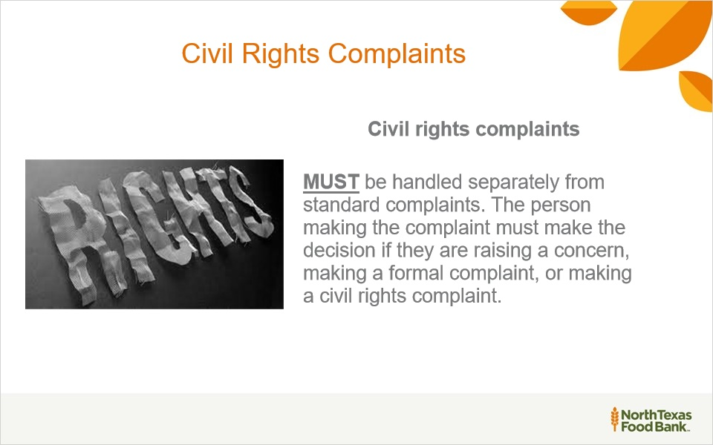
Notes:
Click on the resource tab to take you directly to USDA website on how to file a program discrimination complaint to provide as a resource to your neighbors.

1.18 Compliance Reviews
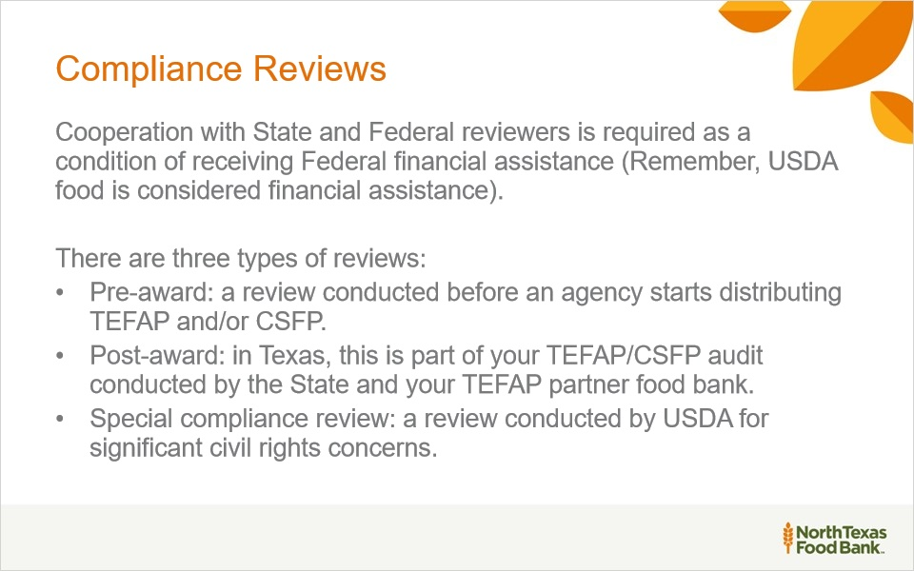
Notes:
NTFB standard of compliance of its partners are based on the standards as set by the state and/or federal programs that support the resources being provided to you. State and Federal governments are required to conduct reviews to determine compliance with civil rights laws, regulations, and requirements.

1.19 Compliance Reviews - Pre-award
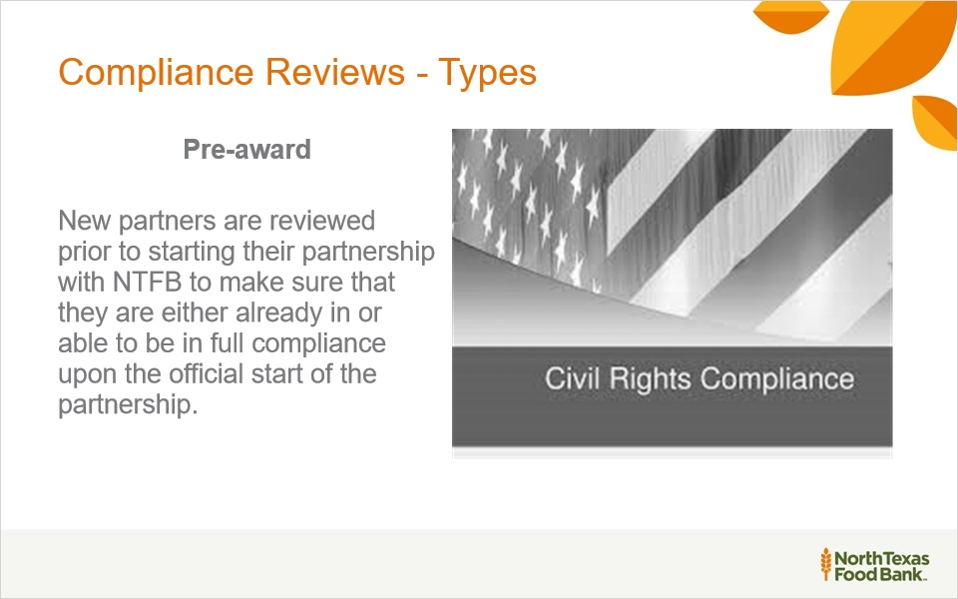
Notes:
Now, let’s discuss the different types of compliance reviews!
The first type is Pre award. All new partners are evaluated prior to beginning a partnership with NTFB.
This is to ensure that they are ready to be in full compliance upon the official start of the partnership.

1.20 Compliance Reviews - Routine/post award
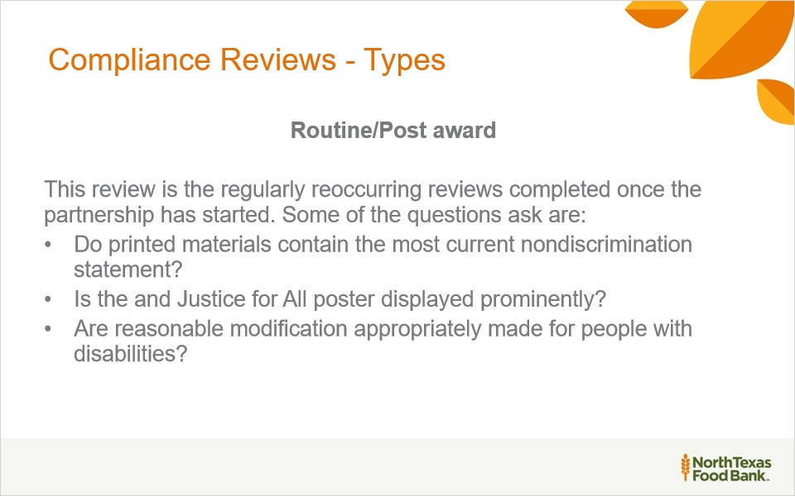
Notes:
Now, let’s discuss the different types of compliance reviews!
The second type is Post award. Once the partnership has started, the review process is reoccurring.
expected questions to be asked, could be: "Is the justice for all poster displayed prominently?

1.21 Compliance Reviews - Special
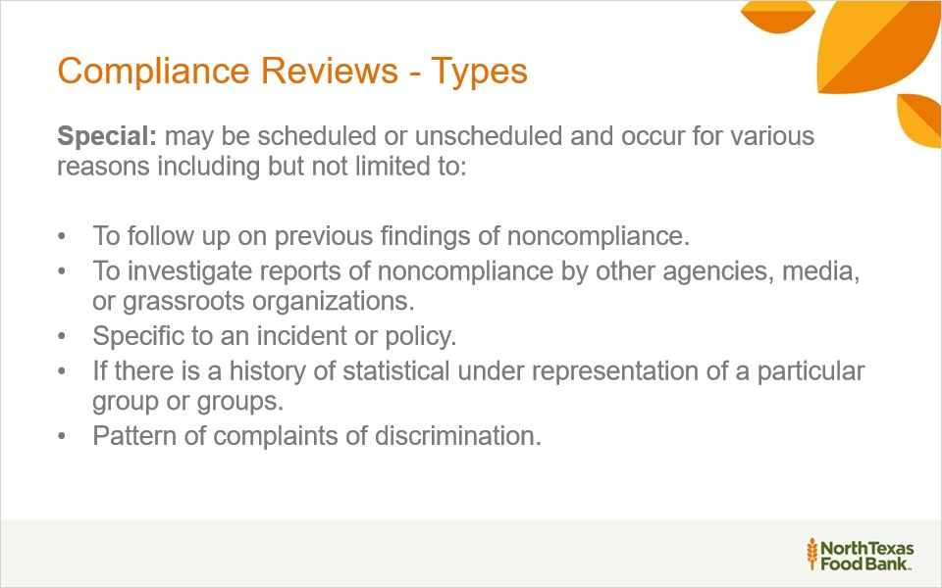
Notes:
The next type of compliant review is: Special review. Once the partnership has started, the review process is scheduled or unscheduled. Reasons for special review could be a follow up on a previous noncompliance issue, any incidents to a specific policy, or any pattern of complaints of discrimination.

1.22 Resolution of Noncompliance
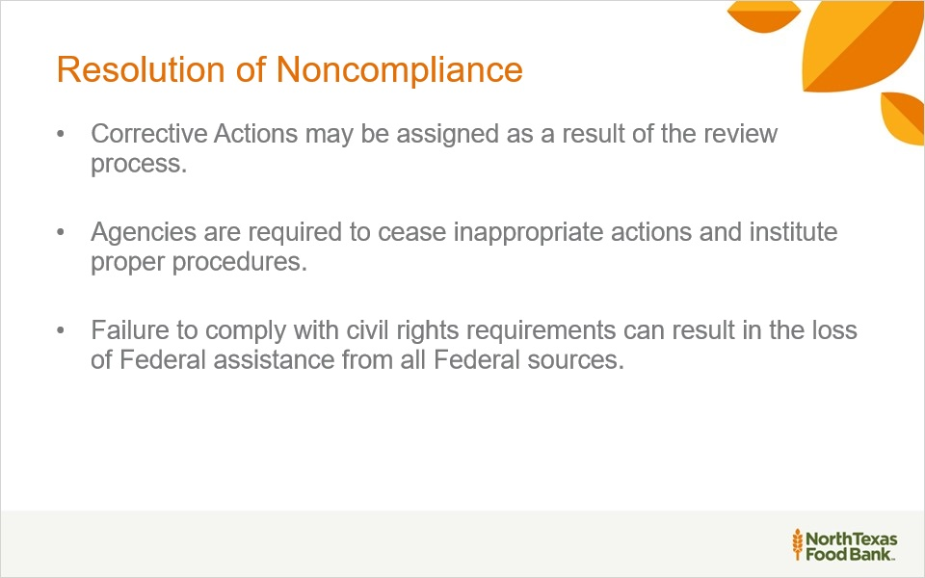
Notes:
Resolution of Noncompliance

If there are any noncompliance issues, corrective actions may be assigned as part of the review process. Agencies will need to discontinue improper actions and begin to instate proper procedures.
Remember, failing to comply with civil rights requirements can lead to loss of all Federal sources or assistance.

1.23 Collection and Use of Data
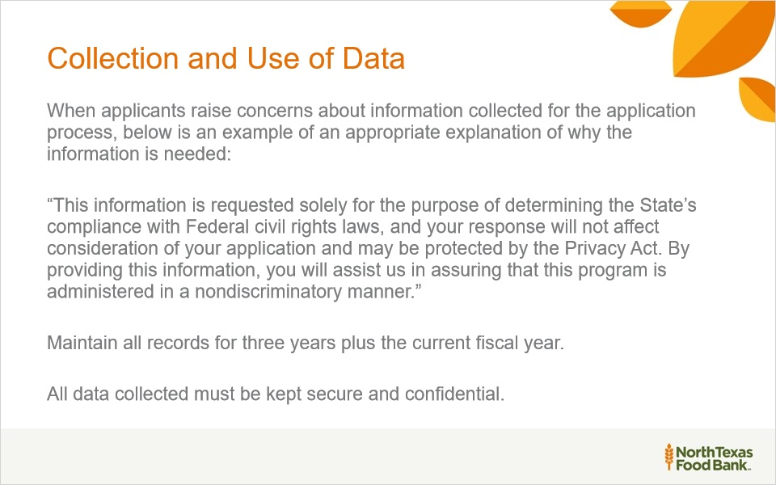
Notes:
Federal Food & Nutrition Service (FNS) policy requires agencies and institutions at every level of our network to collect data relating to ethnicity and race from clients applying for their programs, with the exception of those applying for The Emergency Food Assistance Program (TEFAP). All pantry organizations, on-site kitchens, and produce partners associated with NTFB are operating under the rules and regulations of TEFAP.

1.24 Collection and Use of Data (Cont.)
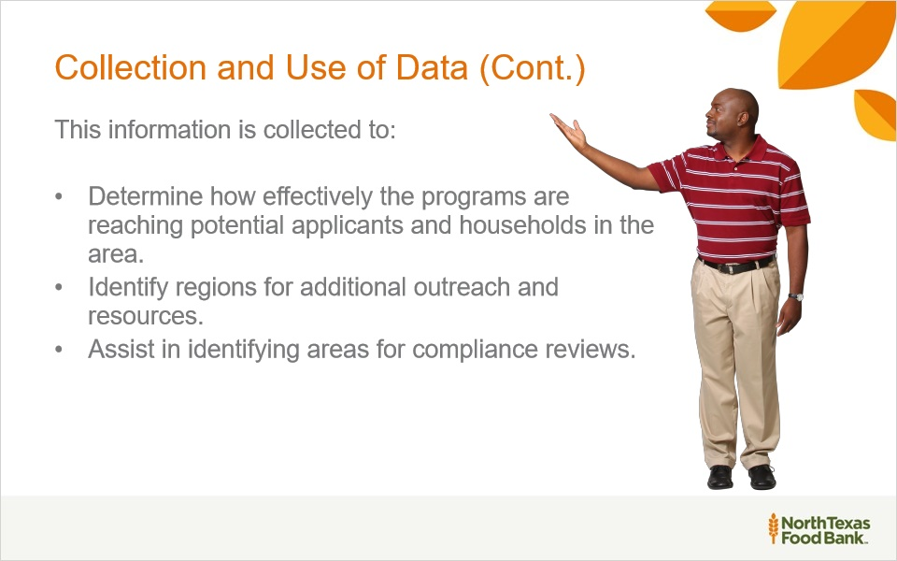
Notes:
Collection and Use of Data
The data that is collected is used for many reasons. Some of those reasons are determining how effective the programs are in reaching households,
analyze areas for additional outreach and resources, and assist in areas for determining compliance reviews.

1.25 Customer Service
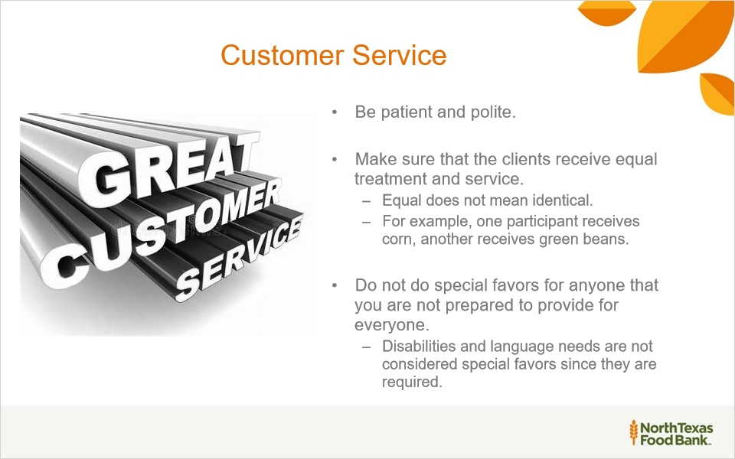
Notes:
Providing quality customer service is key to meeting the needs of your customers. Customer service is effectively communicating with your customers, responding to their needs, valuing their worth, and instilling excellence through courtesy, confidence, and enthusiasm. Treat everyone with dignity and respect and make people feel welcomed.

1.26 Customer Service cont.
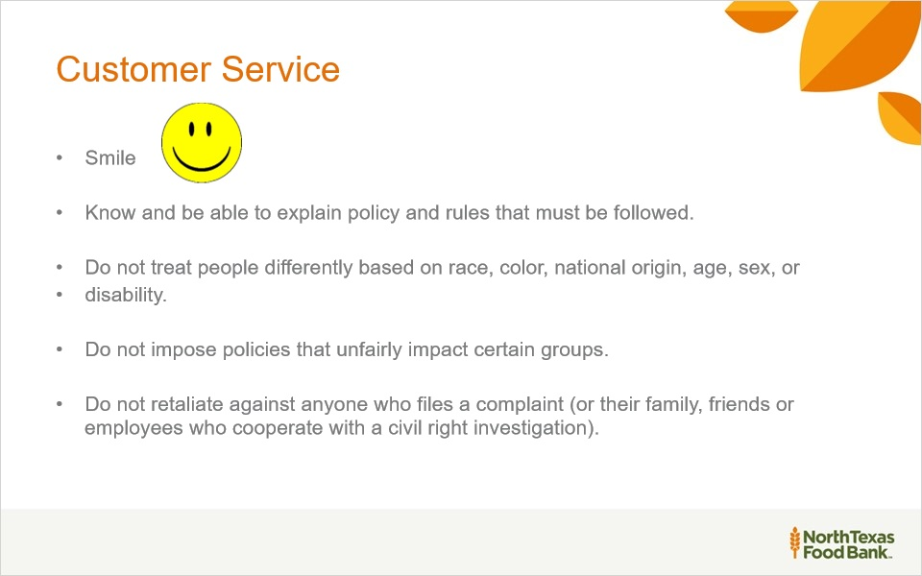
Notes:
Exercise good listening skills by being attentive to the customer and their needs. Learn to empathize with the customer, when necessary. Recognize and appreciate that customers have many needs and few resources. Recognize changes in a customer’s demeanor, because it often signals the person feels they have been treated in a rude, discourteous, or unfair manner.

1.27 Practice some Do’s and Don'ts
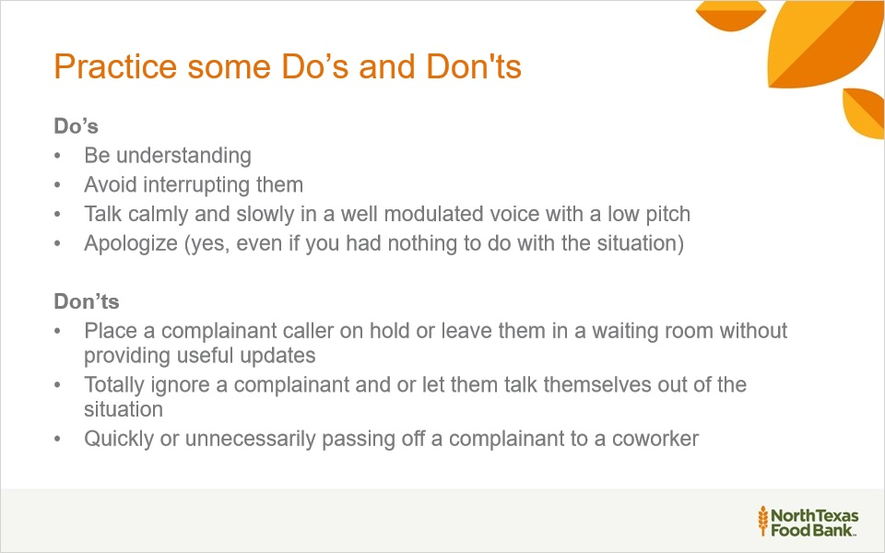
Notes:
Some other considerations, Do, Identify the problem based on the information the customer gives you and determine a solution and personally follow up to make sure the customer has been satisfied and the issue is resolved. Don’t provide an excuse and say Sorry it’s not my job.

1.28 Customer Service Final Thoughts
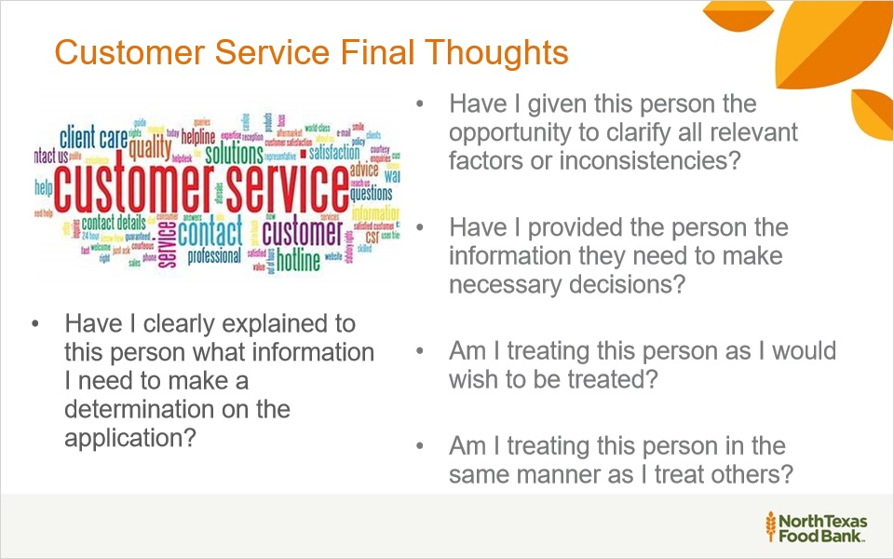
Notes:
In order to minimize the risk of a civil rights discrimination complaint, ask yourself the following questions each time an applicant and/or participant comes to your program.

1.29 Conflict Resolution
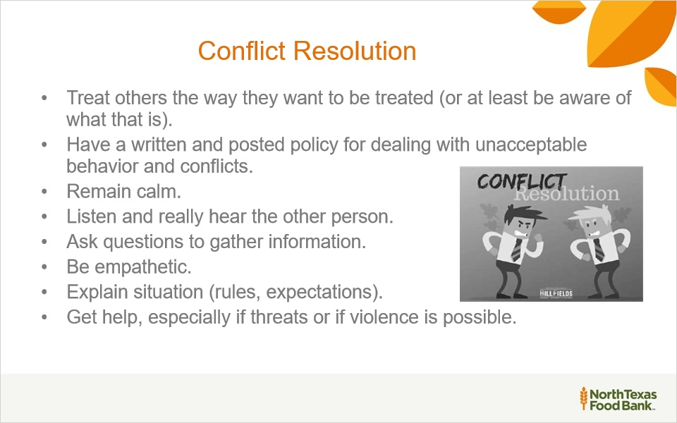
Notes:
Now let’s discuss how to approach conflict resolution and the best approaches if things don’t work out. Here are some successful ways to approach an unpleasant situation.

1.30 Conflict Resolution cont.
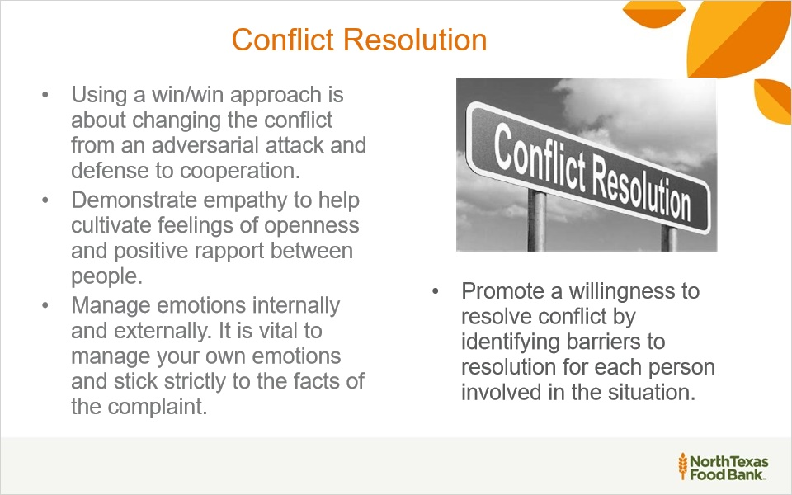
Notes:
Remember the person and the conflict are not the same. Finally, if a customer files a Civil Rights complaint or participates in an investigation, it is unlawful to treat that person differently. Plus, retaliation is unacceptable and against the law.

1.31 Reasonable Accommodation
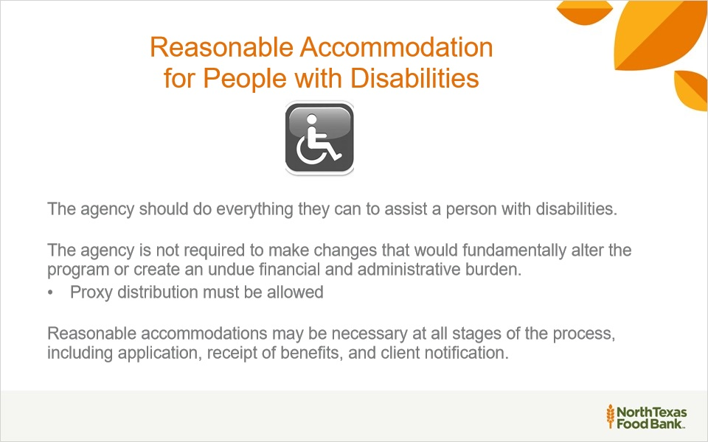
Notes:
A reasonable accommodation is a change in rules, policies, practices, or services so that a person with a disability will have an equal opportunity to apply for and receive TEFAP and/or CSFP food.

1.32 Limited English Proficiency
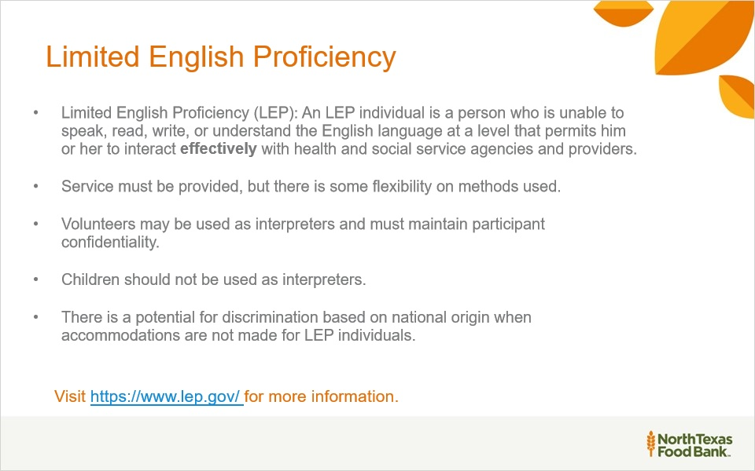
Notes:
Limited English Proficiency

Please review this slide in detail and visit www.lep.gov for more information.

1.33 Accommodations
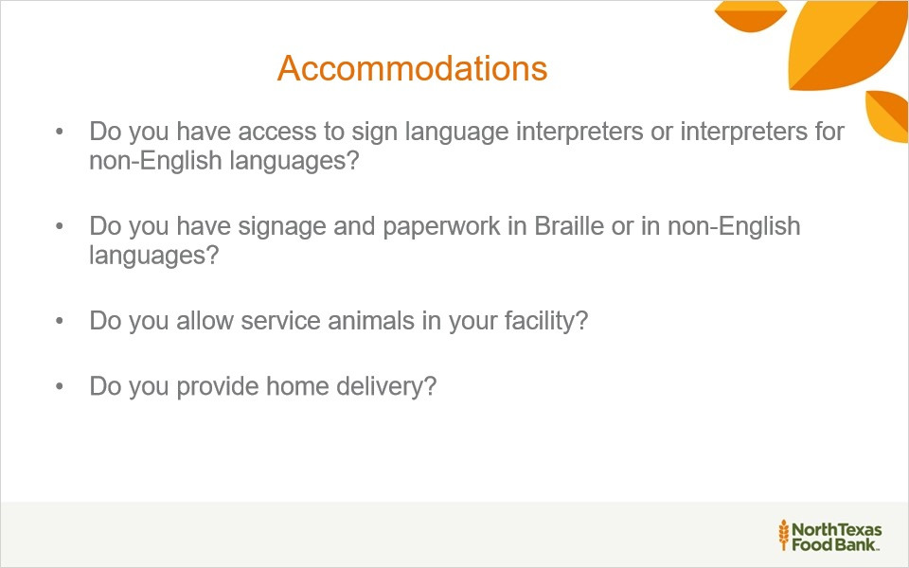
Notes:
Is your distribution site accessible? Consider the parking lot, entrances, exits, hallways, elevators, and restrooms.

1.34 What is Reasonable
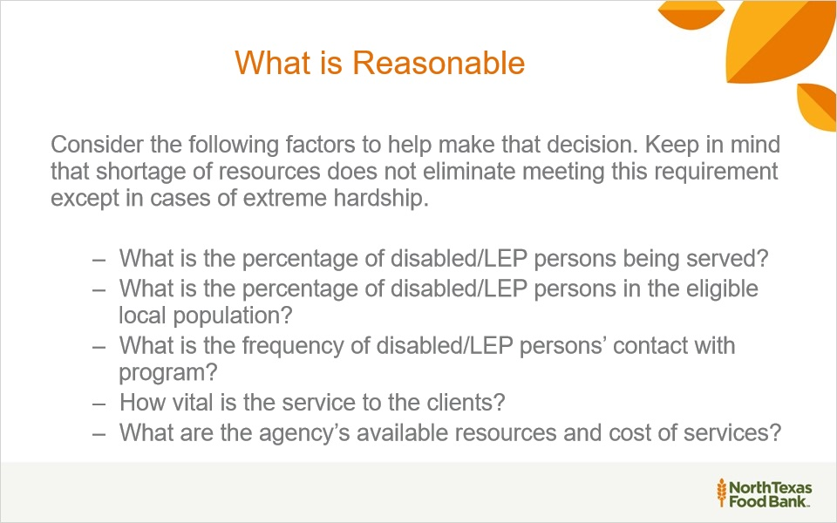
Notes:
When do I have to translate TEFAP/CSFP applications into another language or place a ramp to gain entry to the building?

1.35 Equal Opportunity for Religious Organizations
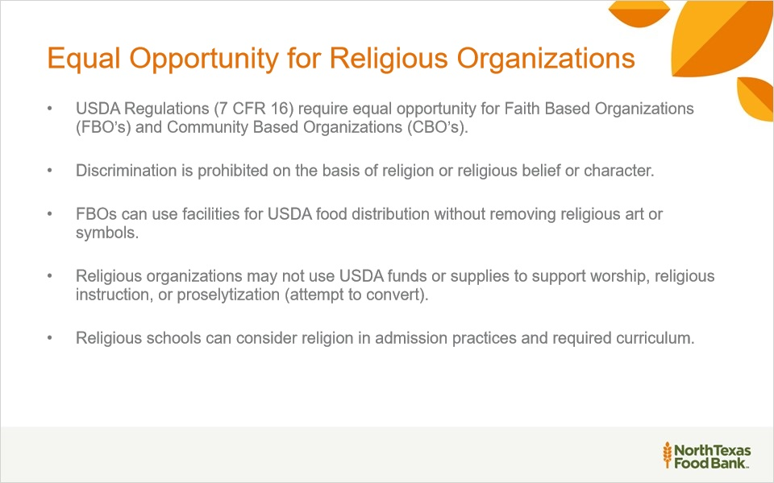
Notes:
Equal Opportunity for Religious Organizations
USDA Regulations require equal opportunity for faith-based organizations and community-based organizations.
Remember that discrimination is illegal based on religion, religious beliefs, or character. Also, religious organizations cannot use USDA funds to support any religious work.

1.36 Religious or Faith-Based Organizations
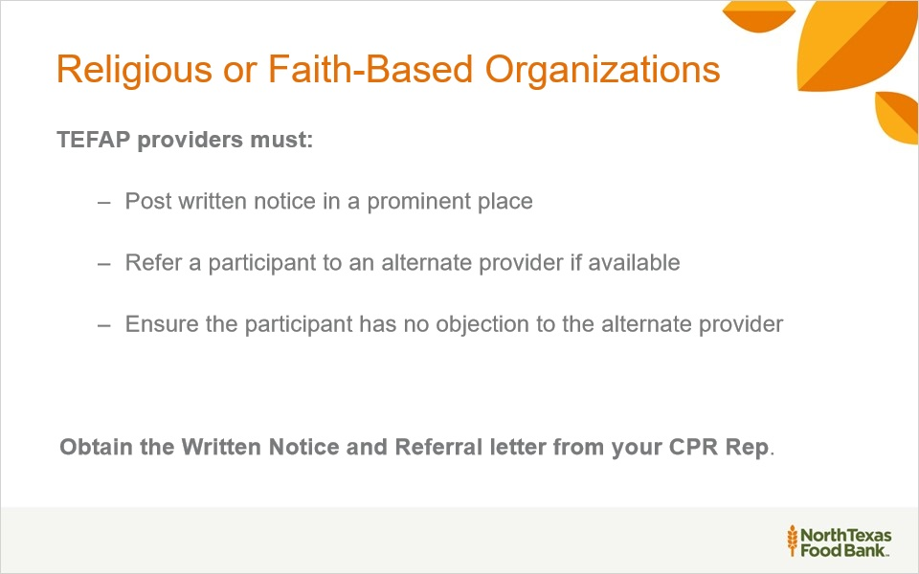
Notes:
Religious or Faith-Based Organizations
TEEFAB providers must do the following: visibly post written notices; refer alternative provider if available if the neighbor desires and ensure the neighbor agrees.

1.37 Thank You- The End

Notes:
The North Texas Food Bank would like to thank you for spending your valuable time participating in this training.
Remember, you can find valuable resources by clicking on the resource tab located in the right top corner of each slide.

